CHAPTER 1
INTRODUCTION

Background
According to statistics, social media is an inevitable part of the Internet, with 1 in every 4 minutes of Internet usage spent on social media (GlobalWebIndex, 2015). Another observation on a social media named Facebook, reported that users log in to their Facebook accounts 2 to 5 times a day, with an average of 5 to 15 minutes per session (Quan-Haase & Young, 2010, p. 355).
The different kinds of social media on the Internet accommodate each user’s needs. A seven-block framework on the functions of social media was proposed (Kietzmann, Hermkens, McCarthy, & Silvestre, 2011, p. 241), in which one of these blocks is the identity block. The identity block represents how users consciously or unconsciously reveal their identities on social media. They may consciously fill out information about themselves, or unconsciously show their identities through their behavior on social media.

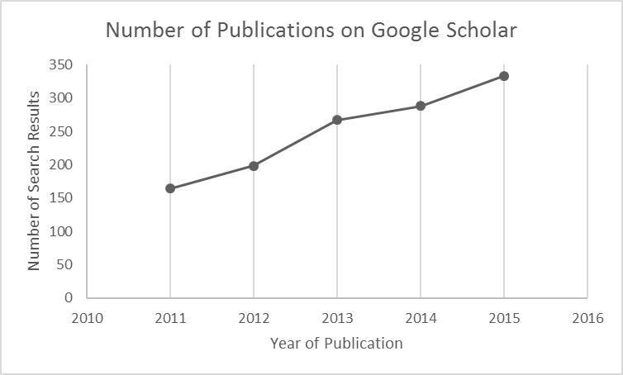
Figure 1.1 Number of Publications Per Year Graph
(Source: Google Scholar)

One of the forms of information which may be extracted from social media data is a user’s personality trait. The traditional method of personality assessment is through identification by psychology experts, but this method is costly and time-consuming. Throughout the years, various computational approaches have been proposed to predict one’s personality automatically through their social media usage. Figure 1.1 shows the number of publications on Google Scholar from year 2011 to 2015 when searched with the keyword “personality (prediction OR recognition OR classification)”.
The task of automated personality assessment (hereinafter referred to as personality prediction), has been applied to several social medias. One such social media which is often used to perform said task is Twitter. Figure 1.2 shows the number of active Twitter users worldwide for each quarter from year 2012 to 2016. Twitter has gained high popularity over the years, reaching up to 313 million active Twitter users as of June 2016 (Twitter Inc, n.d.), and with 2.4% of tweets worldwide posted by users of Jakarta (Carley, Malik, Kowalchuck, Pfeffer, & Landwehr, 2015), the capital city of Indonesia. Mr. Roy Simangunsong, Indonesia’s Twitter Country Head, reports that 77% of Indonesians are active on Twitter every day (CNN Indonesia, 2016).

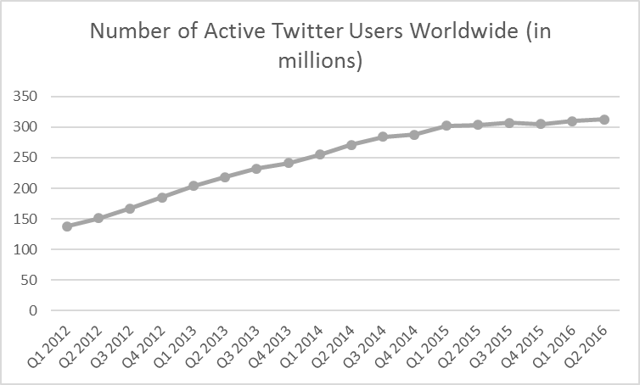
Figure 1.2 Number of Active Twitter Users Worldwide in Millions from 2012-2016
(Source: Twitter Investor Relations 2014, 2016)

Figure 1.3 shows the number of Twitter users in Indonesia per year from year 2014 to 2019. As depicted in the graph, the number of users from 2014-2015 increased, and is predicted to further increase each year until 2019. Due to such a heavy usage on Twitter, this social media platform has been utilized as data source in several tasks such as sentiment analysis (Farzindar & Inkpen, 2015 p. 47; Melville, Sindhwani, & Lawrence, 2009, p. 3), named entity recognition (Li et al., 2012, p. 721-730; Ritter, Clark, & Etzioni, 2011, p. 1524-1534), automatic summarization (Hariardi, Latief, Febryanto, & Suhartono, 2016, p. 575-579; Kågebäck, Mogren, Tahmasebi, & Dubhashi, 2014, p. 31-39; Lin & Bilmes, 2011, p. 510-520), and personality prediction (Arroju, Hassan, & Farnadi, 2015, p.1-10; Lima & de Castro, 2013; Pratama & Sarno, 2015, p. 170-174; Sumner, Byers, Boochever, & Park, 2012, p. 386-393).

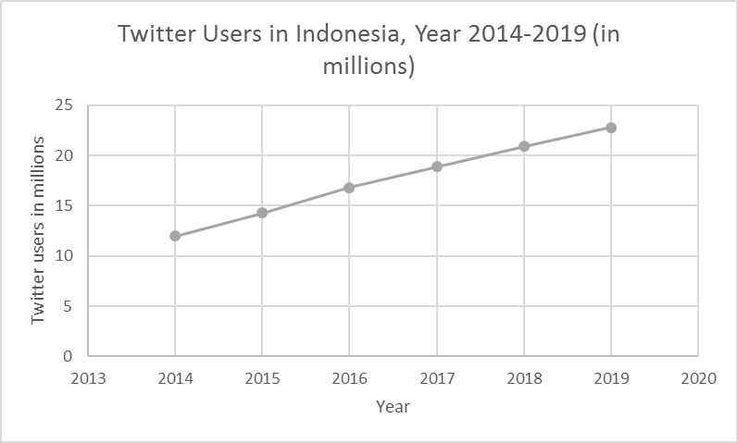
Figure 1.3 Number of Twitter Users in Indonesia Per Year 2014-2019 in Millions
(Source: eMarketer, 2015b)

Several studies in the past have conducted this task using the Big Five personality model which is commonly referred to as the Five Factor model (Arroju et al., 2015; Lima & de Castro, 2013, p. 195; Pratama & Sarno, 2015, p. 170). The Five Factor model is a personality model which divides personalities into 5 traits, namely Openness to Experience, Conscientiousness, Extroversion, Agreeableness, and Emotional Stability. This model is based on factors which are stable over the lifetime, appear in many cultures, and are valid predictors of emotions and behaviors (Schultz & Schultz, 2008, p. 293).
More insight can be gained about a certain individual by assessing his/her personality. Several studies have shown that a personality assessment may reveal one’s important life outcomes, such as education, income, mortality, and relationships (Judge, Livingston, & Hurst, 2012, p. 390-407; Komarraju, Karau, Schmeck, & Avdic, 2011, p. 427-447 ; Roberts, Kuncel, Shiner, Caspi, & Goldberg, 2007, p. 313-345).
In this era, smartphone has become an important object which represents the future of modern communication (Kratzer et al., 2014, p. 3). Figure 1.4 shows the number of smartphone users in Indonesia from year 2014 to 2015, and the predictions until year 2019. As depicted in Figure 1.4, there are 55.4 million smartphone users in Indonesia in the year of 2015, and its numbers are predicted to continually grow each year. This increase shows the importance of smartphones in Indonesia.

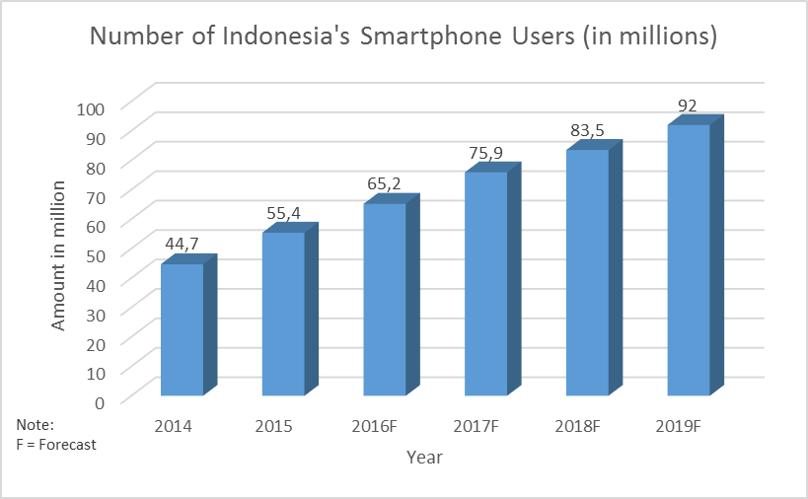
Figure 1.4 Statistics On the Number of Smartphone Users in Indonesia
(Source: eMarketer, 2015a)

These smartphones run on different kinds of operating systems. Figure 1.5 shows the percentage of operating systems that are used in smartphones in Indonesia from January 2016 to July 2016. As seen from the chart, Android has the biggest market share in Indonesia compared to other operating systems. This means that the number of potential users that can be reached for a certain application is bigger when developed on an Android platform compared to the rest.

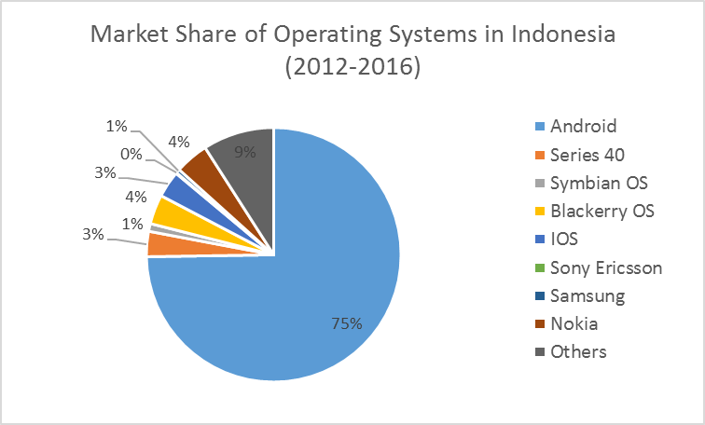
Figure 1.5 Pie Chart of Market Share Held by Mobile Operating Systems in Indonesia from January 2012 to July 2016
(Source: Statista, 2016a)

Based on the outline above, this study aims to conduct the personality prediction task based on The Five Factor model and utilizing social media features from Twitter. The tweets that are considered for this study are tweets in Indonesian language, since not much research has been done to perform personality prediction for said language. This system is then implemented into an Android operating system. The machine learning algorithms applied to this system are Support Vector Machine, a popular classification function (Murphy, 2012, p. 20), and a Gradient Tree Boosting algorithm called XGBoost, which has gained recent popularity from programming competitions (Chen & Guestrin, 2016, p. 785).

Research Question
The problem that is addressed in this research is the possibility of achieving higher accuracy in the creation of a personality prediction system based on Bahasa Indonesia tweets. This problem statement is divided into 3 main research questions, which are as follows.
- Is personality prediction possible using Twitter data, specifically for tweets in Bahasa Indonesia?
The previous research by Pratama & Sarno (2015) was done with an English Facebook dataset, translated into the Indonesian language. The current study aims to improve dataset reliability from the previous study by conducting the personality prediction task on an original Indonesian dataset from Twitter.
- Is it possible to reach a higher accuracy of the personality prediction task compared to the previous study?
The previous study achieved an average accuracy of 65% with their system. This study aims to test whether the different dataset and approach can improve the accuracy from the previous study.
- Among SVM and Gradient Tree Boosting, which will perform better in personality prediction?
The machine learning algorithms applied to this system are SVM and XGBoost’s Gradient Boosting Tree, due to its advantages (which will be further explained in Chapter 2.1.4.2). The two algorithms will then be compared for its performance.

Hypothesis
Based on the identified research questions, the possible hypotheses which can be reached through this research are as follows.
- Personality prediction via social media in Bahasa Indonesia is possible.
- A higher accuracy of the personality prediction task can be achieved compared to the previous study.
- Gradient Boosting Tree will perform better than SVM.

Scope
The scope defined for this research are as follows.
- The social media utilized in this personality prediction task is Twitter.
- The features that are taken into consideration to predict a user’s personality are the user’s social behavior exhibited on Twitter through various data (number of followers, friends, etc.) and the user’s tweets.
- This personality prediction study involves mainly tweets in Bahasa Indonesia, the main language used by Indonesians.
- The Twitter users involved in this experiment are those whose account aren’t protected (public Twitter users) and those who are still actively tweeting on Twitter.
- The personality model used for the current study is The Five Factor model, which consists of the Openness, Conscientiousness, Extraversion, Agreeableness, and Emotional Stability personality traits.
- The machine learning algorithms which are applied to the personality prediction system for comparison purposes are the Support Vector Machine with Sequential Minimal Optimization (SMO) and a Gradient Boosting Tree algorithm with XGBoost.
- This study implements a simple rule-based slang word normalization technique. A complex slang word normalization technique is beyond the scope of this research.
- The current study doesn’t take personality masking in social media (the act of concealing the natural personality of oneself on social media) into consideration.
- The personality prediction application is built for the Android operating system.
- The current study focuses on building the personality prediction system rather than the application.

Purpose and Benefit

Purpose
The purposes of this research are as follows.
- Improve personality prediction accuracy compared to previous studies.
- Develop personality prediction system based on user behavior and tweets from Twitter users, specifically for tweets in Indonesia language.
- Creating an application that can automatically assess an individual’s personality.
- Implement the developed personality prediction application into the Android operating system.

Benefit
The benefits from the outcome of this research are as follows.
- Aids society in the task of understanding an individual through their personality, which is helpful in various fields.
- Help someone understand themselves through their personality traits for self-development purposes.
- Contribution to the field of automated personality assessment.

Research Method
The following are the research methods which are applied to this research.
- Feasibility study
Feasibility study involves assessing whether a task is possible. This method is in accordance with this study’s first research problem, which is assessing whether personality prediction using Twitter data, specifically for tweets in Bahasa Indonesia.
- Comparative study
Comparative study involves the observation of two different techniques, which in this case is observing the performance of two different algorithms: Support Vector Machine with SMO and Gradient Boosting Tree with XGBoost.
- Literature survey
In this study, literature survey involves studying previous related works on personality prediction. A literature survey provides insight on what milestones have been achieved in previous studies and what further improvements need to be done for the study.

Organization of Thesis
The organization of this thesis consists of 5 chapters that explains the general overview of this thesis, as follows:
- CHAPTER 1 INTRODUCTION
Chapter 1 describes the background of personality prediction system development from Twitter, the research questions, hypotheses, scopes, purposes, benefits, research methods, and the organization of this thesis.

- CHAPTER 2 LITERATURE REVIEW
Chapter 2 explains about the theoretical basis that are used for the current research, “Personality Prediction Program Using Bahasa Indonesia Twitter Based on The “Five Factor Model” by McCrae and Costa”. Theoretical basis is based on explanation from books, papers, and other related research articles. This chapter also explains about previous researches related to this study.

- CHAPTER 3 METHODOLOGY
Chapter 3 explains about the methodology and flowchart applied to the personality prediction system’s development such as dataset preparation, building the system and implementation of the system.

- CHAPTER 4 RESULT AND DISCUSSION
Chapter 4 presents the system specifications in the testing environment, result of the prediction accuracy based on scenario, evaluation result from interview with respondents, and objective evaluation with previous research.

- CHAPTER 5 CONCLUSION AND IMPROVEMENTS
Chapter 5 presents the conclusion from this study and future improvements which could be applied to the current study.

